Exp No 8: Practice Queries using Aggregate functions, Group By, Having Clause and Order by Clause.

SELECT MIN(Price) FROM Products;

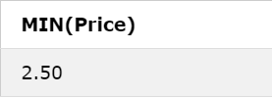

SELECT MAX(Price) FROM Products;

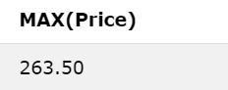

SELECT AVG(Price) FROM Products;

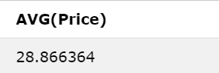

SELECT COUNT(ProductID) FROM Products;

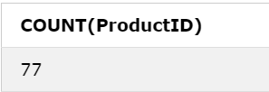

SELECT SUM(Price) FROM Products;

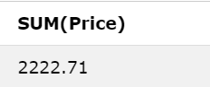

SELECT COUNT(CustomerID), Country FROM Customers GROUP BY Country;

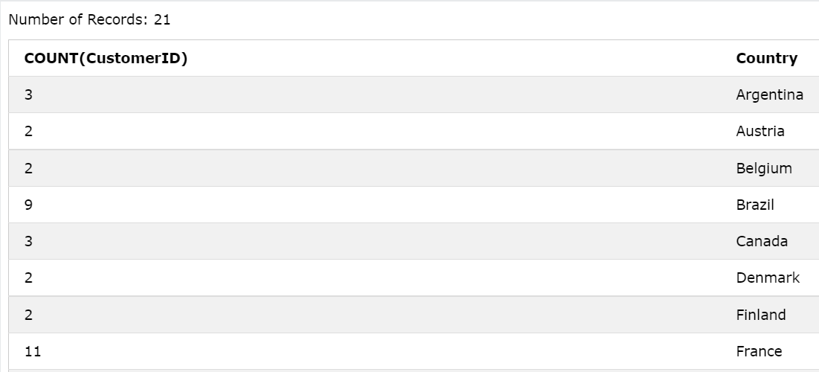

SELECT COUNT(CustomerID), Country FROM Customers GROUP BY Country HAVING COUNT(CustomerID) > 5;

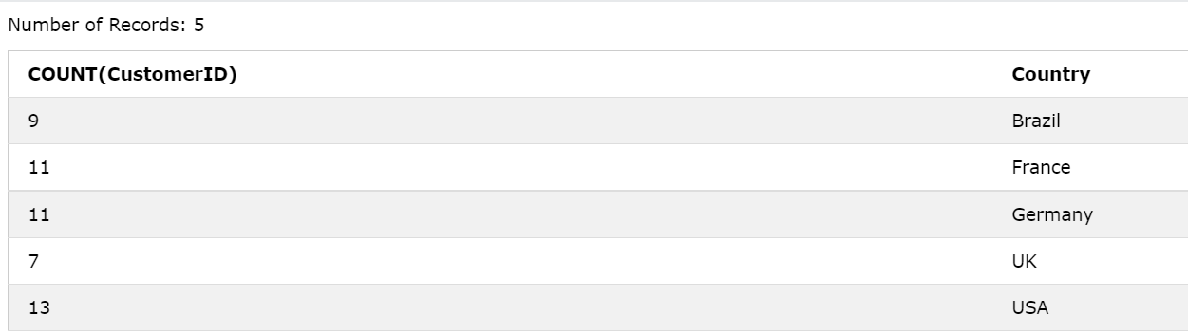

SELECT \* FROM Customers ORDER BY Country DESC;

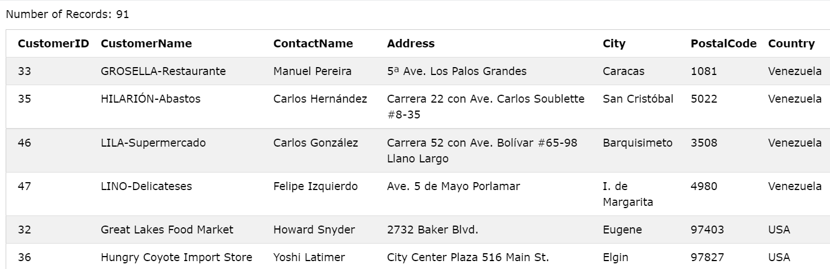

SELECT \* FROM Customers WHERE CustomerID = 1;

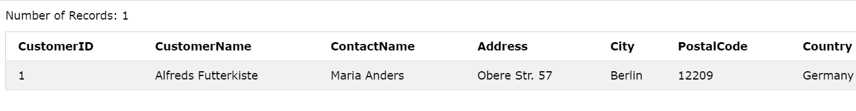

SELECT \* FROM Customers WHERE CustomerID <> 1;

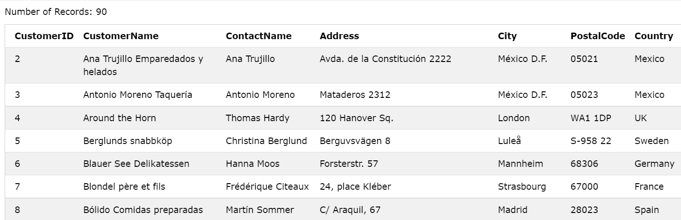

SELECT \* FROM Customers WHERE CustomerName LIKE 'a%';

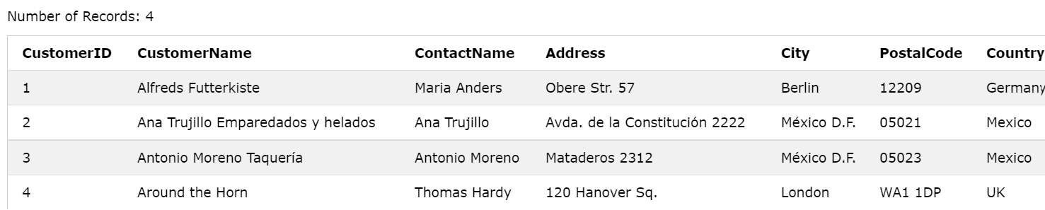

SELECT \* FROM Customers WHERE Country = 'Germany' AND City = 'Berlin';

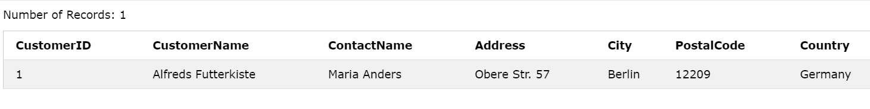

SELECT \* FROM Customers WHERE Country = 'Germany' OR City = 'Berlin';

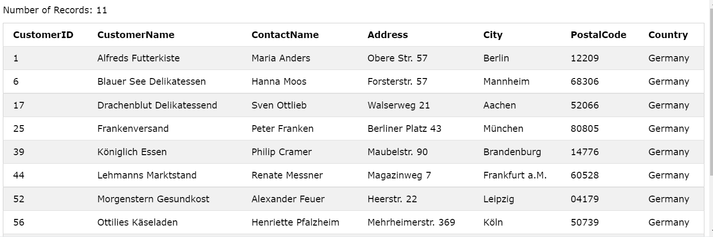

SELECT \* FROM Customers WHERE NOT Country = 'Germany';

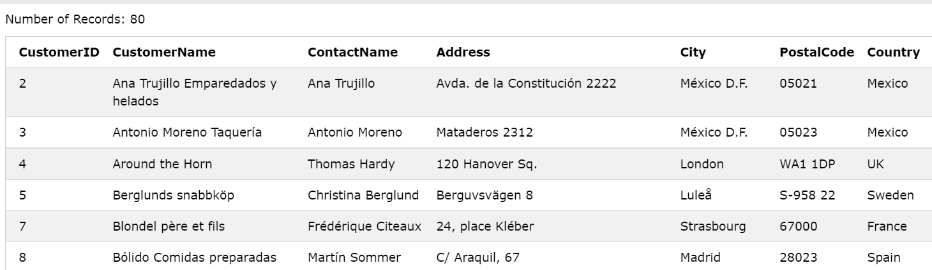

CREATE VIEW [Brazil Customers] AS SELECT CustomerName, ContactName FROM Customers WHERE Country = 'Brazil';

SELECT \* FROM [Brazil Customers];

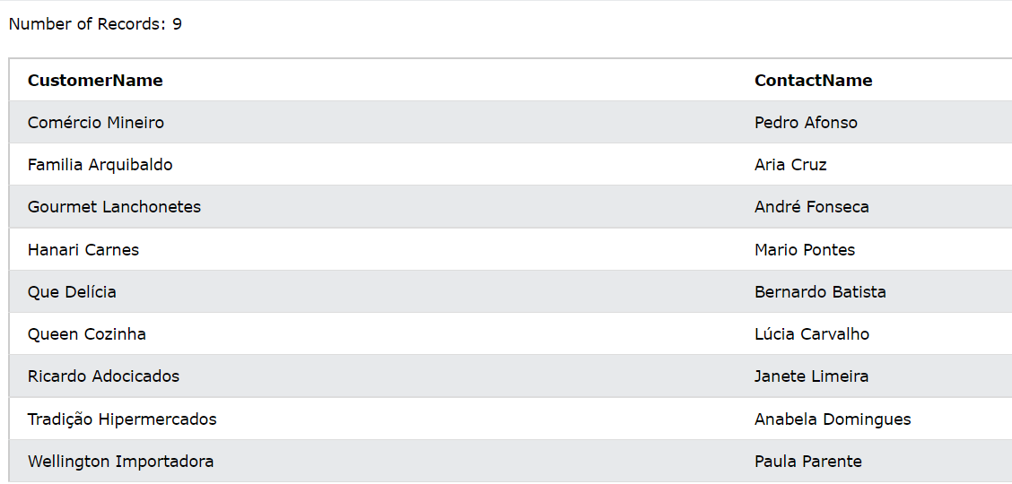

DROP VIEW [Brazil Customers];